Worry balloons
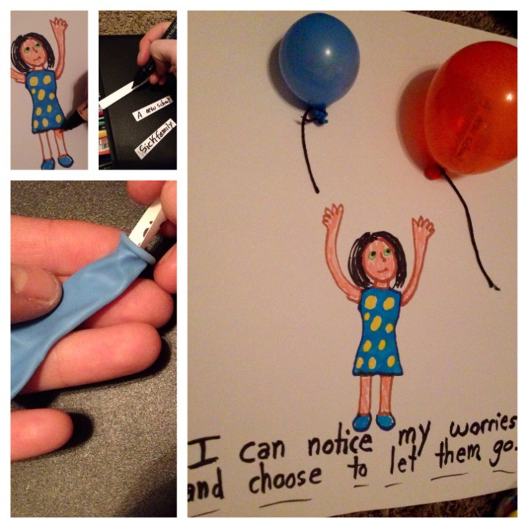
One of my favorite child meditations is to invite a child to imagine they are breathing their worries, troubles, or triggers into balloons. Then I have the child imagine they are simply noticing the worry without judging it. When they are ready, they can choose to let the worry go and watch it as it gets smaller and smaller into the sky.
I made this art activity to go with the meditation.
1) Ask the child draw themselves.
2) Help the child write or draw worries on small pieces of paper. Be sure to validate their worries and encourage them to notice their worries without judging them.
3) Place the worries inside of balloons.
4) Blow up the balloons (make sure you use small balloons or blow them up small enough to fit on the picture).
5) Attach or draw strings to the balloons and tape the balloons to the paper as a visual reminder for this new coping skill!
I have children use this guided imagery technique before bedtime and it really helps with sleep.

